Greendale Stadium Case
The G&E Company is preparing a bid to build the new 47,000 seat Greendale baseball stadium. The construction must start July 1, 2011, and be completed in time for the start of the 2014 season. A penalty clause of $100,000 per day of delay beyond May 20, 2014, is written into the contract.
Ben Keith, the president of the company, expressed optimism at obtaining the contract and revealed that the company could net as much as $2 million on the project. He also said if they are successful, the prospects for future projects are quite good since there is a projected renaissance in building classic ball parks with modern luxury boxes.

CASE APPENDIX: TECHNICAL DETAILS OF THE GREENDALE BASEBALL STADIUM
The baseball stadium is an outdoor structure with a retractable roof. The project begins with clearing the site, an activity that lasts 70 days. Once the site is clear, work can start simultaneously on the structure itself and demolishing an adjacent building site. This demolition is necessary to create a construction stage for storing materials and equipment. It will take 30 days to demolish the buildings and another 70 days to set up the construction site.

TABLE 6.3 Greendale Stadium Case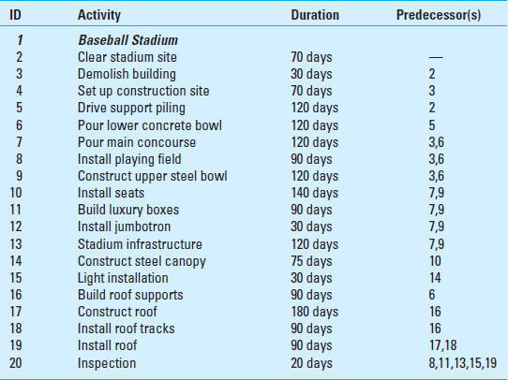

The work on the stadium begins by driving 160 support pilings, which will take 120 days. Next comes the pouring of the lower concrete bowl (120 days). Once this is done and the construction site has been set up, then the pouring of the main concourse (120 days), the installation of the playing field (90 days), and the construction of the upper steel bowl can occur (120 days).
Once the concourse and upper bowl are completed, work can start simultaneously on building the luxury boxes (90 days), installing the seats (140 days), installing the jumbotron (30 days), and installing stadium infrastructure (120 days) which includes: bathrooms, lockers, restaurants, etc. Once the seats are installed then the steel canopy can be constructed (75 days) followed by the installation of the lights (30 days).
The retractable roof represents the most significant technical challenge to the project. Building the roof track supports (90 days) can begin after the lower concrete bowl is constructed. At this time the dimensions of the roof can be finalized and the construction of the roof at a separate site can begin (180 days). After the roof supports are completed then the roof tracks can be installed (90 days). Once the tracks and the roof are completed then the roof can be installed and made operational (90 days). Once all activities are completed it will take 20 days to inspect the stadium.

For purposes of this case assume the following:
- The following holidays are observed: January 1, Memorial Day (last Monday in May), July 4th, Labor Day (first Monday in September), Thanksgiving Day (4th Thursday in November), December 25 and 26.
- If a holiday falls on a Saturday then Friday will be given as an extra day off, and if it falls on a Sunday then Monday will be given as a day off.
- The construction crew work Monday through Friday.

